Practical 3
Aim : Implementing character count using python and mapReduce

Step 1: Create a text file with some text and store it in some folder(Here we have stored it in charCount folder)
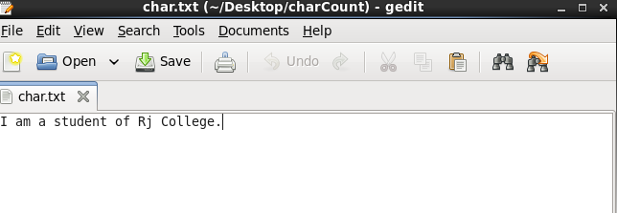

Step 2 : Create a mapper function in the same folder. Here we name the file as mapper.py
Code :
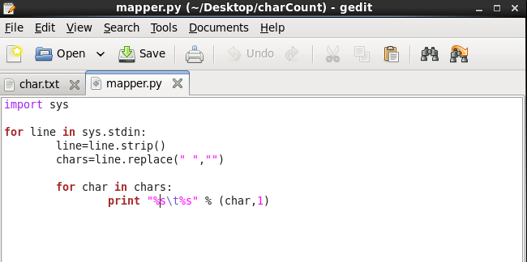

Step 3 : Create a reducer function in the same folder. Here we name the file as reducer.py
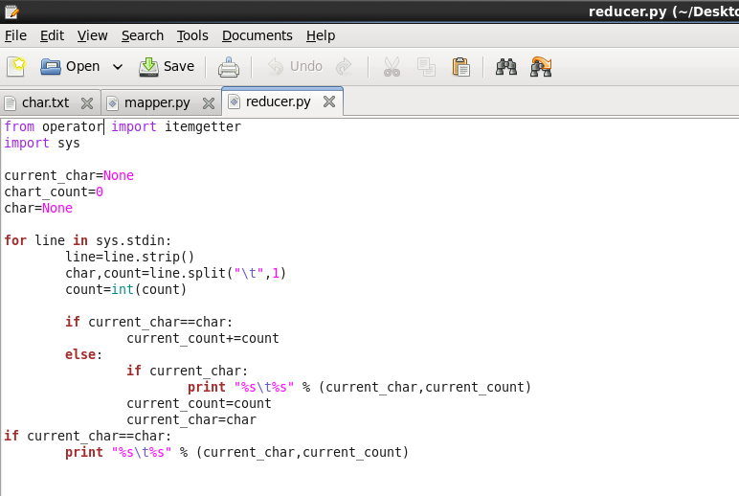

Step 4 : First we check our present working directory using “pwd” command.
Then we browse into the “charCount” folder by using cd “location of the charCount folder”

